**Ideation Phase**

**Empathize & Discover**

|  |  |
| --- | --- |
| Date | 19 September 2022 |
| Team ID | PNT2022TMID07729 |
| Project Name | Crude oil price prediction |
| Maximum Marks | 4 Marks |

**Empathy Map Canvas:**

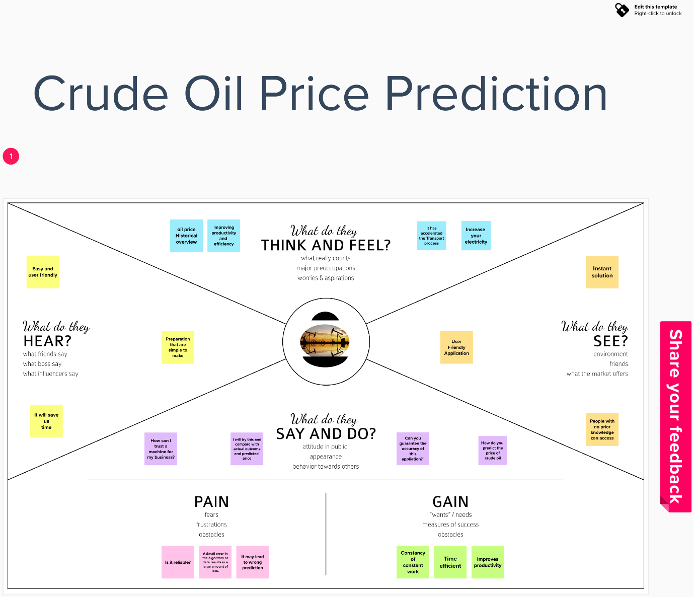

**Reference:https://app.mural.co/invitation/mural/ibm7868/1663407313871?sender=u0bf93a6bfafab0f9ccad2595&key=a1730951-a7d1-4ada-96e4-5e55f3b583cd**